附件：

[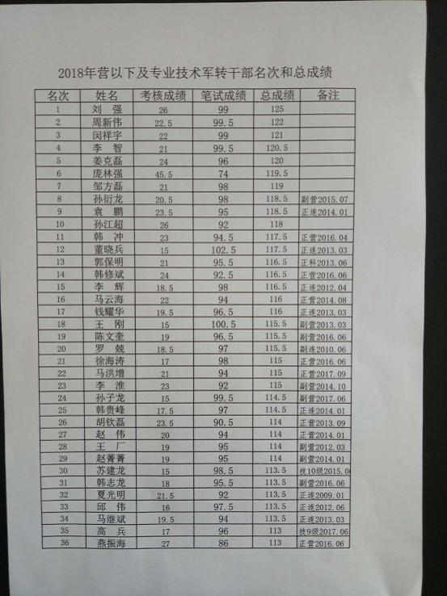](http://hrss.zibo.gov.cn/picture/0/55a31c872338487f8cb25a52e4a2af72.jpg)

[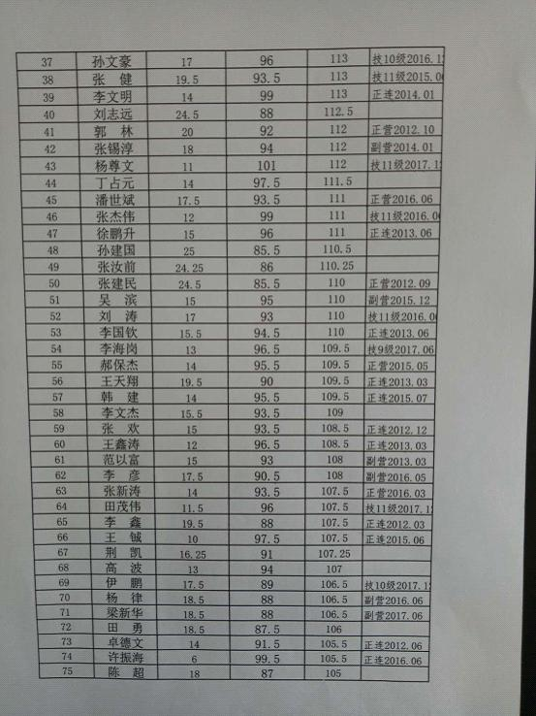](http://hrss.zibo.gov.cn/picture/0/37a344bcac1046a4aed8603e5122029a.jpg)

